Apps For Android and iPhones
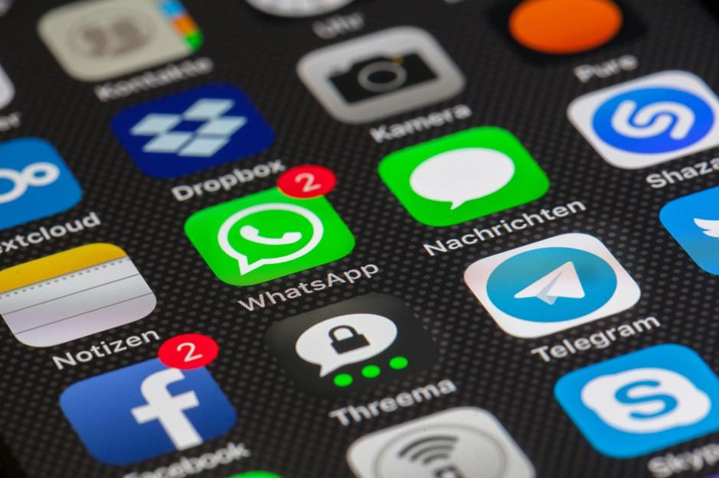
Users of Android phones get their apps from Google Play, which currently has more than 600,000 apps available. Most of these apps will also run on Android tablets except for the Kindle Fire, which has a separate app store with a smaller selection of apps. Many apps that were originally available only on Apple iOS are now available for Android, including Instagram and Pinterest. Google’s open development platform means other apps are also available, including Adobe Flash Player and BitTorrent. Of course, Android phones can also access other Google-owned services, such as YouTube and Google Docs.
Users of iPhones get their apps from the Apple store, which currently offers 700,000 apps. More than 250,000 of these apps are also available for Apple’s iPad. Most developers prefer to develop games for iOS before they develop for Android. Apple iOS offers some exclusive apps, including the popular game Infinity Blade and the Twitter client Tweetbot.
Note: Most popular apps are available for both platforms. But for tablets, there are more apps designed specifically for the iPad; Android tablet apps are often scaled up versions of Android smartphone apps.
Note: Most popular apps are available for both platforms. But for tablets, there are more apps designed specifically for the iPad; Android tablet apps are often scaled up versions of Android smartphone apps.

